Data assimilation activities at EARS
January - August 2010

September 16^{16th}, 2010
Benedikt Strajnar, Jure Cedilnik

Pre-operational assimilation suite
1.1 Status
ALADIN assimilation suite at 4.4 km is still in the pre-operational phase and was running daily over the period, but with some delay with respect to operational runs. It uses OPLACE observations and some local non-GTS data. There was a problem with 2m T and 2m RH from SYNOP station, which were accidentally blacklisted by NOTVAR namelist arrays in the minimization. An impact of that is being estimated by rerunning the suite for a month of June 2010.

1.2 Recent changes in the assimilation cycle
A considerable amount of time spent on local data assimilation developments was devoted to resolving a problem with packing of ALADIN fields. There appeared a wrong (negative) surface temperature that, after a couple of assimilation steps, caused a crash in model integration during first guess creation. The intermediate solution was to switch off the packing and finally to apply packing only to surface variables by adding a namelist switch NVGRIB_SURF.

1.3 Bias correction scheme

Static bias correction is used to correct the satellite radiances. Variational bias correction is now under evaluation in a parallel suite with initial VARBC file taken from Meteo France operational ALADIN assimilation cycle (file VARBC.merge).

1.4 B-matrix

The background error statistics were recomputed and are now based on 450 forecast differences from June 2007, using ensemble technique. The coupling model was ARPEGE ensemble assimilation.

1.4 Verification with respect to operational suite

The verification scores are roughly the same as for operational 4.4 km model run (using dynamic adaptation). There are some degradations recently near the surface, which were probably introduced by lack of 2m SYNOP data (figure 1). A precipitation verification or case studies are needed to more deeply investigate the impacts of assimilation.

Research topics

1.2 Diagnosis and tuning of background, observational and model error in AROME

The aim of this work was to use the available methods of “a posteriori” diagnostics to estimate and tune observational and background error. Using the findings, we aim at estimating the model error contribution to background errors.

This work relies on the idea that one can estimate model errors as a fraction of background errors. So that model error contribution Q can be written as Q = αB, where B is the background error covariance matrix. The α can be estimated by the comparison of expected background covariances, in a perfect model framework, with diagnosed values.

Most of the work was devoted is devoted to diagnosing the true background and observational error standard deviations by means of “a posteriori” diagnostics. Two suitable methods, introduced by Desroziers and Ivanov (2001) and Desroziers et al. (2005), were used. The daily evolution of the ratio between diagnosed and specified error standard deviations according to the first method is shown on figure 2. The a posteriori diagnostic methods used here are known to be efficient only in case when correlation structures in background and observational error covariance matrices differ sufficiently. While such separation in the correlation structure is not questionable for a global model like ARPEGE (with the background error length scales of few hundreds of kilometers), it becomes an issue for high resolution models. This problem reflects also in the different results obtained by two used methods.

As a side product, we explored the DFS (degrees of freedom for a signal) of different observation types used in the AROME assimilation (figure 3). It turned out that SYNOP, AIREP and radar observations play the most important role in the analysis.

The a posteriori diagnostics were also applied to ARPEGE model. We expected to observe larger
background standard deviations in ARPEGE than AROME because the former contains less represented scales, which help the model to be able to represent the observed variability. On the other hand, background errors are expected to be larger in AROME because there is more uncertainty in the smaller scales. We could confirm this expectation (e.g. for wind in figure 4).

Before estimating the model error, we performed the tuning experiments using the diagnosed error variances. It turned out that the tuning does not significantly modify the quality of the subsequent forecasts.

Using these findings, we can finally obtain an indirect estimate of model error fraction α . Using two methods, we found quite different values of α=0.64 and α=1.54. However, the accumulated model error contribution is of approximately the same magnitude as expected background error, provided by the perfect framework approach (e.g. with ensemble or NMC methods). In ensemble data assimilation, one could use such fraction to inflate the short-range forecasts, used as a backgrounds for analysis, and therefore improve the simulation of model error.

1.3 Estimation of LBC impact on B-matrix calculation

A comparison was carried out in order to estimate the impact of a choice of coupling model on the background error covariances, computed with a limited area model and using the ensemble method. The background errors (B matrix) were computed over a period of July 2007 by downscaling ARPEGE and ECMWF ensemble assimilation members. The comparison shows slightly higher average variances of background error for ARPEGE, which might be a consequence of higher resolution of this coupling model. There are also some visible differences in multivariate couplings, especially for divergence – geopotentiel couplings (figure 5).

1.4 Use of LandSAF albedo products for better initialization of model albedo and snow cover assimilation

The work on albedo assimilation was the continuation of evaluation of use of LandSAF albedo for initialization of model albedo with a simple Kalman filter. The entire software was recoded in a more modular way that is supposed to allow operational implementation (FA files used for cycling and data manipulation instead of some generic binary format) and some bugs were removed, also a full year assimilation cycle was performed and the impact was analyzed through entire year. Time-series were also analysed for some stations where certain physical fluxes are measured. Figure 6 shows yearly evolution of PBL height and sensible heat flux differences if using or not the LSAF albedo information in the model. The figure shows that the albedo assimilation can have large impact on the PBL height (up to 100 m increase). The most impact is visible over the spring and fall as these are the periods when the albedo (through the vegetation) changes fast.

Detailed analysis showed that use of LSAF albedo acts as a systematic bias correction for screen level parameters. To further analyze that, another experiment was performed where there would be no impact of the driving model on surface: full surface blending was and only LandSAF albedo was considered as source of new information.

The first step in work on snow assimilation was to correctly set-up existing snow assimilation in CANARI (in model experiment with full 3Dvar). This consisted of replacing snow mass assimilation (snow height was simply multiplied by 0.01 to obtain snow water equivalent in kg/m2) with snow height assimilation, where values for density are taken from first guess (model snow density). Further, CANARI code was modified in such way to allow for cycling of errors of analysis. The analysis error is stored in a separate file and then read again in the initialization at the next step of assimilation cycle.

The next big step was to recode and adopt algorithm which defines snow cover based on values of LSAF albedo. This algorithm was developed by Dominique Carrer. It is close to the SnowCover LSAF product, but offers some more flexibility and better defines regions with possible snow cover.

Finally, all three pieces were linked together in an assimilation procedure in the following order:
    - snow cover extend is extracted from the LandSAF satellite product by a simple algorithm and merged with first guess with the following simple set of rules:
      - when there is no snow in the model and snow cover in satellite retrieval:
→ 10 cm of snow is added,
    - when there is snow in the model and no snow in satellite imagery:
→ snow is removed,
    - the background error for snow height is modified in the following way:
    - old one (previous analysis error) is used as basis
    - physical fluxes related to precipitation are added (in absolute value) to it:
      - precipitation flux
      - sublimation flux
      - snow melting flux
This addition of physical fluxes is supposed to keep the value of error under control, so that it would not drift too low. Than the CANARI snow assimilation (in snow height) is performed based on satellite modified first guess, and unless it is a cold start, the background sigma values are read from the separate file, after they were modified as explained above. Figure 7 shows an example of difference after first step of this procedure. The amount of satellite data in that case, however, was rather small.

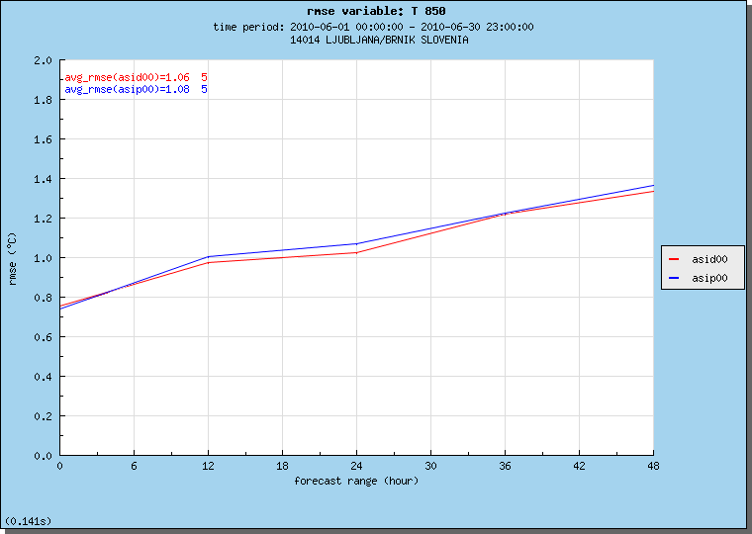
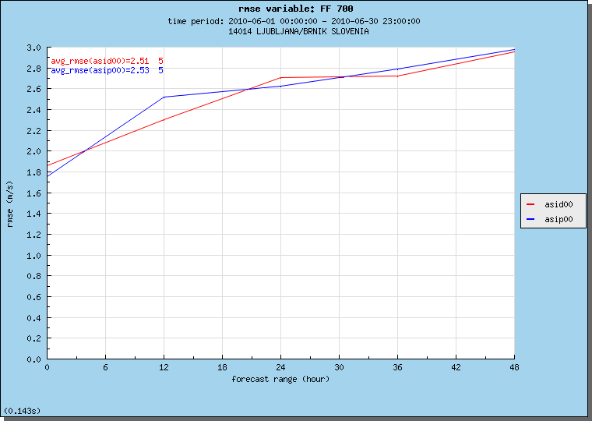

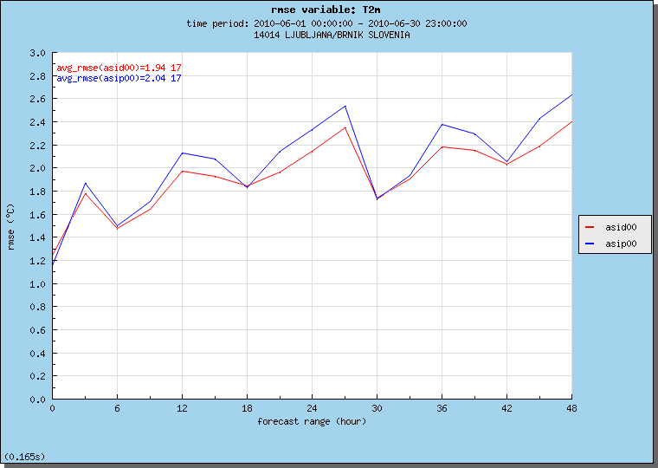
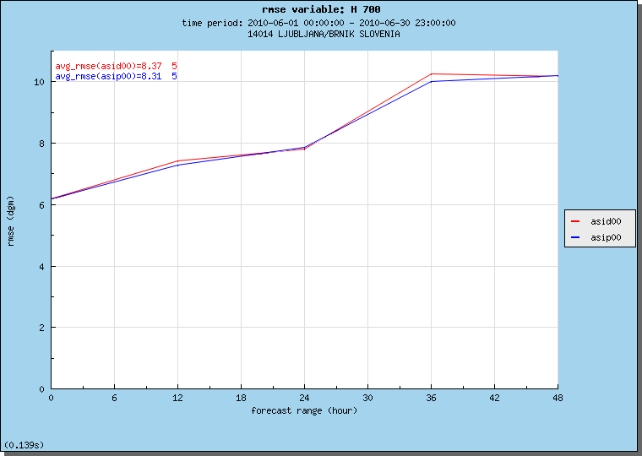

Figure 1: Verification scores of 4.4 km dynamic adaptation (red) and 4.4 km data assimilation runs (blue) for temperature at 850 hPa (top left), wind speed at 700 hPa (top right), T2m (bottom left) and 700 hPa relative humidity (bottom right).
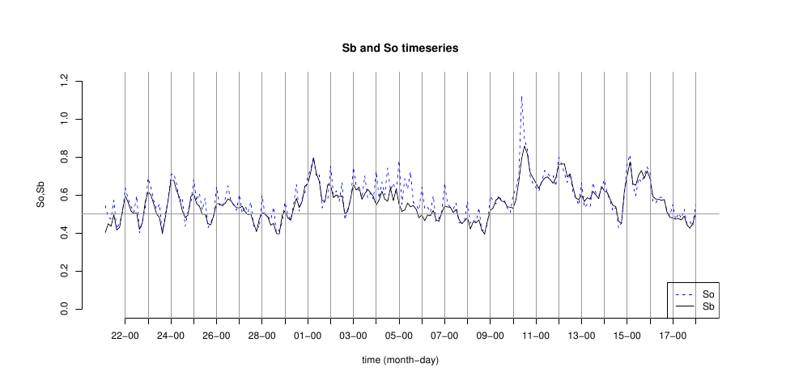

Figure 2: The daily evolution of the ratio between predefined and diagnosed observational (So) and background (Sb) error standard deviations.
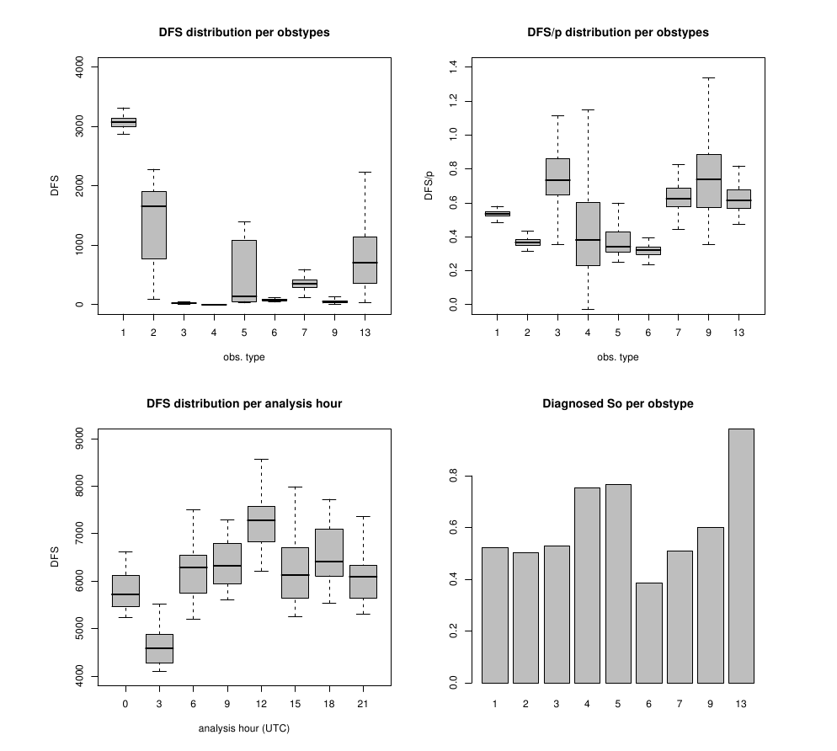

Figure 3: Degrees of freedom for a signal for all observation types used in AROME assimilation.
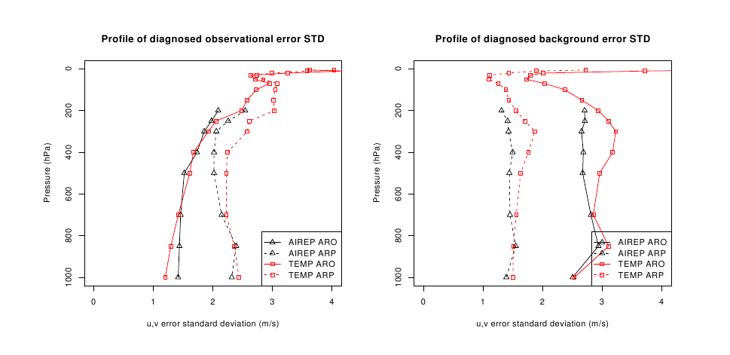

Figure 4: The impact of model resolution (ARPEGE vs. AROME) on diagnosed observational and background standard deviation for wind.

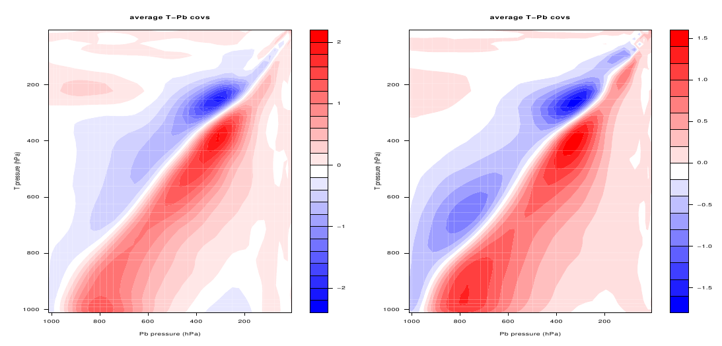

Figure 5: Comparison of T – balanced geopotentiel covariances, computed by ensemble method. 6h forecasts are coupled to ARPEGE (left) and ECMWF (right) global assimilation ensembles.

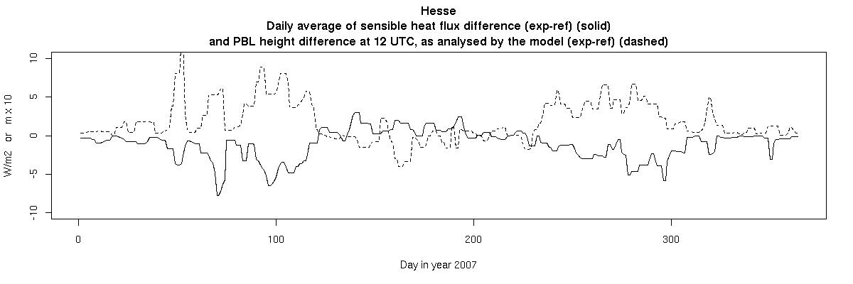
Figure 6: Time series of daily average sensible heat difference [solid line] and PBL height at 12 UTC [dashed line] (experiment with use of LandSAF albedo vs. reference).

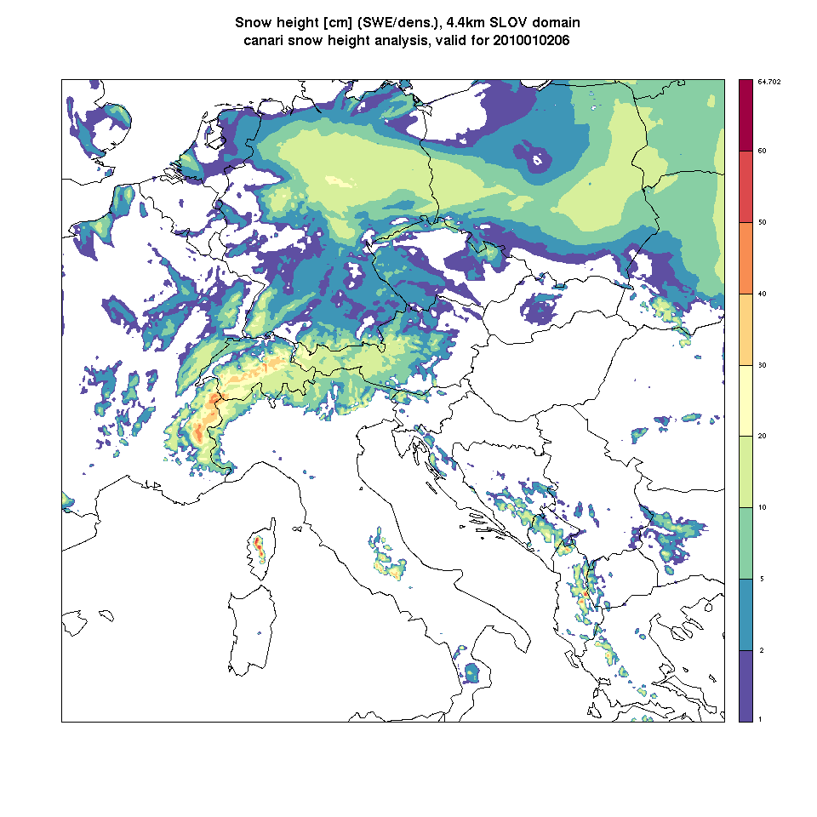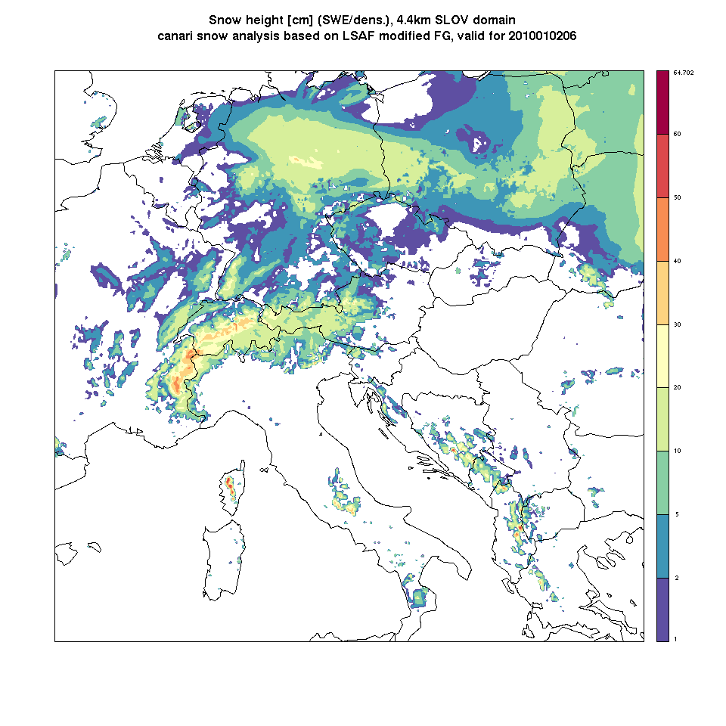
Figure 7: Comparison of SYNOP CANARI snow analysis in (snow height) (left) to CANARI SYNOP snow based on first guess modified by snow cover analysed with albedo LSAF (right).

